D479 Task 2 Template

Your Prototype
Name: | Andre-Silver Alcid
ID: | 011933973
Prototype Link:
https://silveralcid.github.io/D479-UXDesign/

https://app.smartsheet.com/b/form/9ca056877de54895a15c4da4ae88836e?Peer%20Request%20ID=REQ06043&Prototype%20Owner=Andre-Silver%20Alcid&Prototype%20Title=Andre-Silver%20Alcid%20C856%20Prototype%20-%20REQ06043&Prototype%20Link=https://silveralcid.github.io/D479-UXDesign/

Five Objective Usability Tasks:
1.What is the size of the island?
2. What currency does Taniti use?
3.What is the population of the island?
4. How many hospitals are located on the island?
5.How many restaurants are on the island?

Your Completed Peer Reviews

Review 1
Name of the Prototype Owner:
Jasmin Milicevic
Your Panopto Review Link:
https://wgu.hosted.panopto.com/Panopto/Pages/Viewer.aspx?id=81f7b737-7f79-44bb-a31d-b1d10104070a

Review 2
Name of the Prototype Owner:
Jesse Greenough
Your Panopto Review Link:
https://wgu.hosted.panopto.com/Panopto/Pages/Viewer.aspx?id=40f3f9b7-0e99-4015-a76b-b1d10105efe6

Review 3
Name of the Prototype Owner:
Gared Barney
Your Panopto Review Link:
https://wgu.hosted.panopto.com/Panopto/Pages/Viewer.aspx?id=1c6e6f16-bcd0-48f0-a42a-b1d10107dc72

Bonus: I also did reviews for five other people!

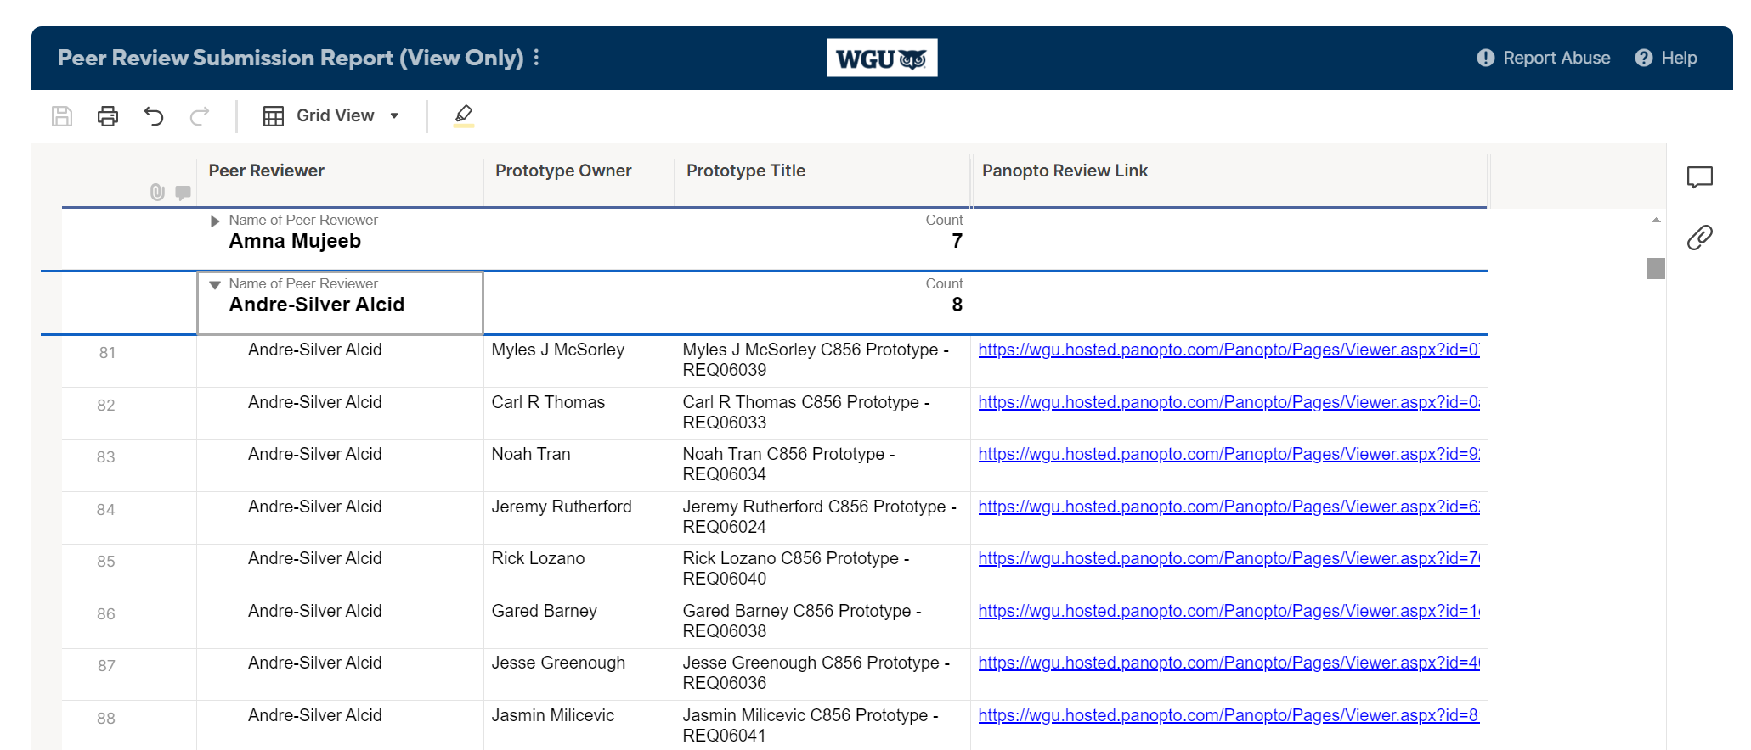

Peer Reviews of Your Prototype

Review 1
Name of Peer Reviewer:
Panopto Review Link:

Review 2
Name of Peer Reviewer:
Panopto Review Link:

Review 3
Name of Peer Reviewer:
Panopto Review Link:

